Created a new Bot called it Rando inside the bot directory

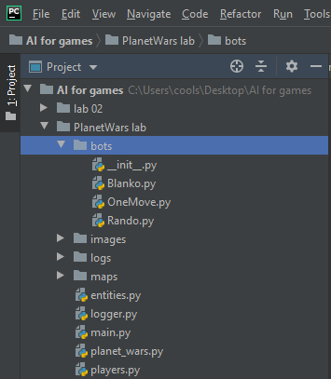

Then added some code that was already provided for the new bot and used it, while also amending the players = [“”] called in the main file, so that it is launches one fleet at a time.



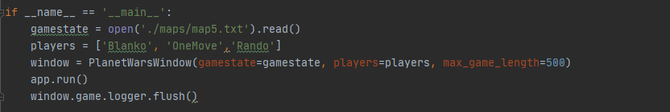Then Used the code provided to carry out below functionality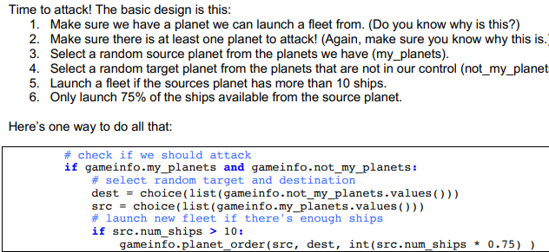

To change the behaviour of the bot from shooting random targets we used the code provided below: where it used the destination point by finding a planet with the minimum number of ships.

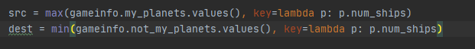

Rando bot:

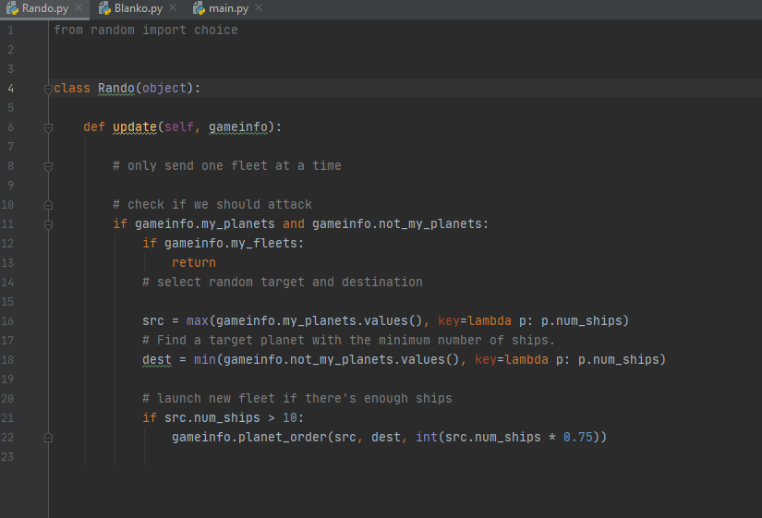

Tried using the other provided bot blanko and tested the inverse proportional search

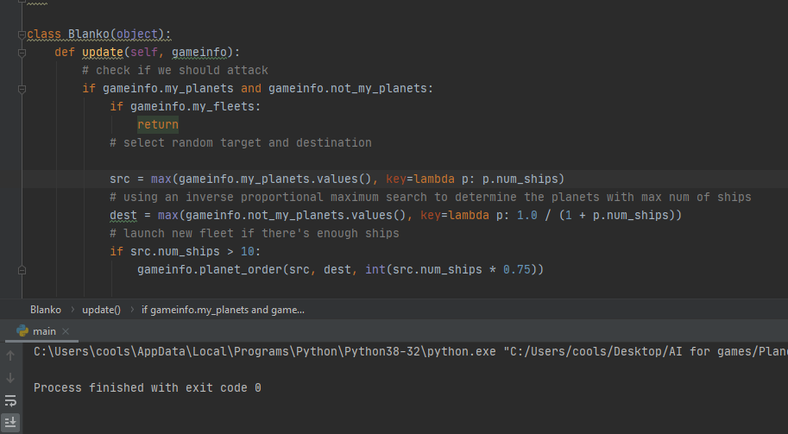

The output was something like this:

